**1: Could you explain the concept of a loosely coupled microprocessor system and provide an example? Additionally, please compare and contrast a loosely coupled microprocessor system with a tightly coupled multiprocessor system.**

Ans:

A loosely coupled microprocessor system refers to a configuration in which multiple microprocessors or processing units work relatively independently of each other. In this setup, each microprocessor typically has its own local memory and performs its own tasks without strong coordination or dependence on other processors. Communication between the processors, if required, is typically achieved through message passing or shared memory mechanisms.

An example of a loosely coupled microprocessor system is a distributed computing network, where several computers are connected together to form a network. Each computer in the network functions as an independent microprocessor and can perform tasks on its own. The computers communicate with each other by sending messages or sharing data through the network. This architecture is commonly used in applications such as grid computing, where a large computational task is divided into smaller sub-tasks that can be processed independently on different machines.

Now, let's compare and contrast a loosely coupled microprocessor system with a tightly coupled multiprocessor system:

1. **Interdependence**: In a loosely coupled microprocessor system, the processors work independently and have limited knowledge of each other. They communicate when necessary but do not rely heavily on each other's operation. On the other hand, a tightly coupled multiprocessor system consists of multiple processors that are tightly interconnected and often share resources such as memory, cache, and peripherals. The processors in a tightly coupled system are highly dependent on each other and work together closely.

1. **Resource Sharing**: In a loosely coupled system, each microprocessor typically has its own local resources, including memory and peripherals. Sharing of resources is limited and usually requires explicit communication between processors. In a tightly coupled multiprocessor system, processors share resources more directly and efficiently. They can access and modify shared memory, exchange data quickly, and coordinate their operations more closely.

1. **Scalability:** Loosely coupled microprocessor systems are generally more scalable because adding additional processors to the system is relatively straightforward. Each new processor can operate independently, and the system can handle a larger number of tasks by distributing them across multiple processors. Tightly coupled multiprocessor systems often have a predefined number of processors, and adding or removing processors may require more complex modifications to the system architecture.

1. **Performance and Coordination**: Tightly coupled multiprocessor systems can achieve higher performance in certain applications that require intensive parallel processing or shared memory operations. The close coordination between processors allows for efficient data sharing and synchronization. In contrast, loosely coupled microprocessor systems may have lower performance due to the overhead of communication and coordination between independent processors.

In summary, a loosely coupled microprocessor system emphasizes independence and scalability, with processors working relatively independently and communicating when necessary. On the other hand, a tightly coupled multiprocessor system focuses on performance and coordination, with processors tightly interconnected and working closely together, often sharing resources to achieve higher processing power.

2: **What is Amdahl’s Law? Describe the role of different registers like IR, PC, SP, AC, MAR and MDR.**

Ans:

Amdahl's Law is a principle that relates to the potential speedup of a computation when only a portion of it can be parallelized. It was formulated by computer architect Gene Amdahl in 1967. The law provides an understanding of the limitations of parallel computing systems and helps in assessing the impact of improving different parts of a system.

Amdahl's Law states that the potential speedup of a computation is limited by the portion of the computation that cannot be parallelized. It can be mathematically represented as:

**Speedup = 1 / [(1 - P) + (P / N)]**

Where:

* Speedup represents the improvement achieved by parallelizing a computation.
* P is the proportion of the computation that can be parallelized.
* N is the number of processors or cores used for parallel execution.

According to Amdahl's Law, even if we increase the number of processors, the maximum speedup achievable is ultimately limited by the non-parallelizable portion of the computation. Therefore, to achieve significant improvements, it's essential to focus on optimizing the parallelizable portion.

Now, let's discuss the role of different registers commonly found in a computer system:

1. **Instruction Register (IR):** The IR holds the currently fetched instruction from memory. It contains the opcode and operands necessary for the processor to execute the instruction.

1. **Program Counter (PC):** The PC keeps track of the memory address of the next instruction to be fetched and executed. After fetching an instruction, the PC is typically incremented to point to the next instruction in the program.

1. **Stack Pointer (SP):** The SP is a register used in stack-based memory architectures. It points to the top of the stack, indicating the memory location where the next push or pop operation will take place.

1. **Accumulator (AC):** The AC is a register that stores intermediate results and operands during arithmetic and logical operations. It is commonly used in simple processor architectures as the primary working register.

1. **Memory Address Register (MAR):** The MAR holds the memory address of the data or instruction to be fetched or stored from/to the memory. It is used to specify the location in memory for memory-related operations.

1. **Memory Data Register (MDR):** The MDR is a temporary storage for the data being transferred between the memory and the processor. It holds the actual data or instruction fetched from or to be written into memory.

These registers play crucial roles in the instruction execution cycle of a processor, facilitating the fetch, decode, and execute stages. They enable efficient data transfer, storage, and manipulation within the processor and interaction with the memory subsystem.

**3: Describe Addressing Mode and its types? Discuss advantages of Addressing Mode.**

Ans:

Addressing mode refers to the way in which the operands or addresses of data are specified in machine instructions. It determines how the processor accesses the data or operands required for an instruction's execution. Different addressing modes provide flexibility and efficiency in expressing memory locations or data sources in instructions.

Here are some common types of addressing modes:

1. **Immediate Addressing**: The operand is directly specified in the instruction itself. It is useful for providing constant values or immediate data to the instructions. For example, ADD R1, #5 adds the value 5 to the contents of register R1.

1. **Direct Addressing:** The memory address of the operand is explicitly specified in the instruction. The instruction directly references a memory location to fetch or store data. For example, MOV R2, [2000] moves the data from memory location 2000 into register R2.

1. **Register Addressing:** The operand is located in a specific register. The instruction specifies the register to be used. For example, ADD R1, R2 adds the contents of registers R1 and R2.

1. **Indirect Addressing:** The instruction specifies a memory address that contains the effective address of the operand. It involves accessing memory twice, first to fetch the effective address and then to fetch or store the data. For example, MOV R3, [R1] moves the contents of the memory address stored in register R1 into register R3.

1. **Indexed Addressing**: The operand is obtained by adding an offset or index value to a base address. It is useful for accessing elements of arrays or data structures. For example, LOAD R4, [R5 + 10] loads the contents of the memory address obtained by adding 10 to the value in register R5.

1. **Relative Addressing**: The address of the operand is specified as an offset relative to the current program counter (PC) value. It is commonly used for branching or jumping instructions. For example, JMP 100 jumps to the instruction located 100 bytes ahead of the current PC.

Advantages of Addressing Modes:

1. **Flexibility:** Different addressing modes provide flexibility in expressing the location of operands or data. This enables programmers to write concise and efficient code, especially when dealing with complex data structures or arrays.

1. **Efficient Memory Access**: Addressing modes like register addressing or immediate addressing allow for fast access to data, as they avoid memory access overhead. These modes make use of processor registers or directly embed the data within the instruction, eliminating the need for memory fetch operations.

1. **Code Optimization**: Addressing modes can help optimize code by reducing the number of instructions required for a specific operation. Efficient addressing modes can lead to shorter and faster programs, improving overall performance.

1. **Enhanced Programmer Control**: Different addressing modes give programmers greater control over how data is accessed and manipulated. This allows for efficient memory utilization, cache optimization, and better overall program design.

In summary, addressing modes play a crucial role in determining how operands or addresses are specified in machine instructions. They provide flexibility, efficiency, and control to programmers, allowing them to write efficient code and access data in various ways.

4: **What is cache mapping? Describe its types with a block diagram.**

Ans:

Cache mapping refers to the technique used to determine how data is mapped from the main memory into the cache memory. It defines the relationship between memory addresses and cache locations. The cache mapping strategy impacts cache performance, including access time, hit rate, and the utilization of cache memory.

There are three commonly used cache mapping techniques:

**1. Direct Mapping:**

In direct mapping, each block of main memory can be mapped to only one specific cache location. The mapping is determined by dividing the main memory address into three fields: the tag field, index field, and offset field. The index field determines the cache set, and the offset field determines the position within the cache set. The tag field is used to compare the requested address with the tag stored in the cache.

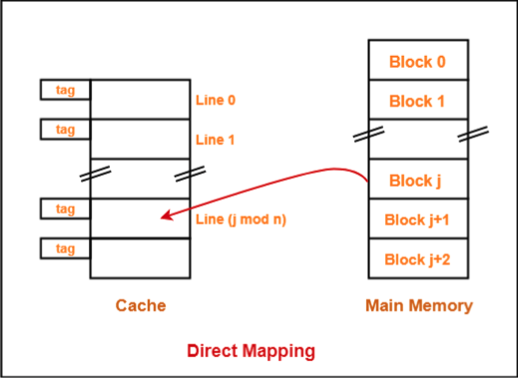**Block Diagram for Direct Mapping:**

**Advantages**: Simple implementation, low hardware complexity.

**Disadvantages:** Limited flexibility, potential for high conflict misses due to limited cache locations.

**2. Associative Mapping:**

In associative mapping, each block of main memory can be placed in any cache location. It allows flexibility in mapping and can store multiple copies of the same memory block in different cache locations. The cache is divided into two fields: the tag field and the data field. The tag field stores the memory block's address, while the data field stores the actual data.

**Block Diagram for Associative Mapping:**

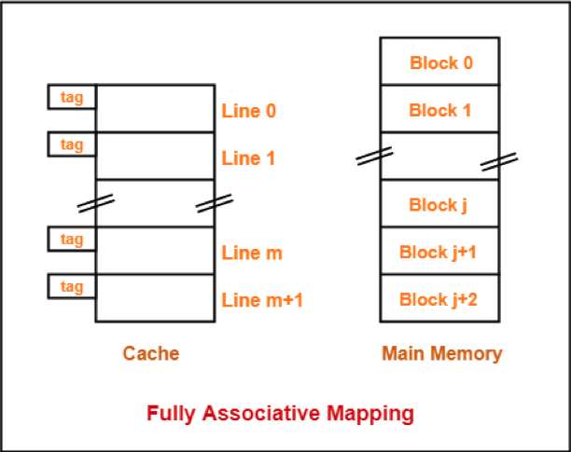

**Advantages:** Maximum flexibility, no conflicts due to free cache location choice.

**Disadvantages**: Higher hardware complexity, longer access time due to parallel searching of tags.

**3. Set-Associative Mapping:**

Set-associative mapping is a compromise between direct mapping and associative mapping. It divides the cache into a set of cache lines, and each cache line can store multiple memory blocks. The cache is divided into two fields: the tag field and the data field. The tag field stores the memory block's address, and the data field stores the actual data.

Block Diagram for Set-Associative Mapping:

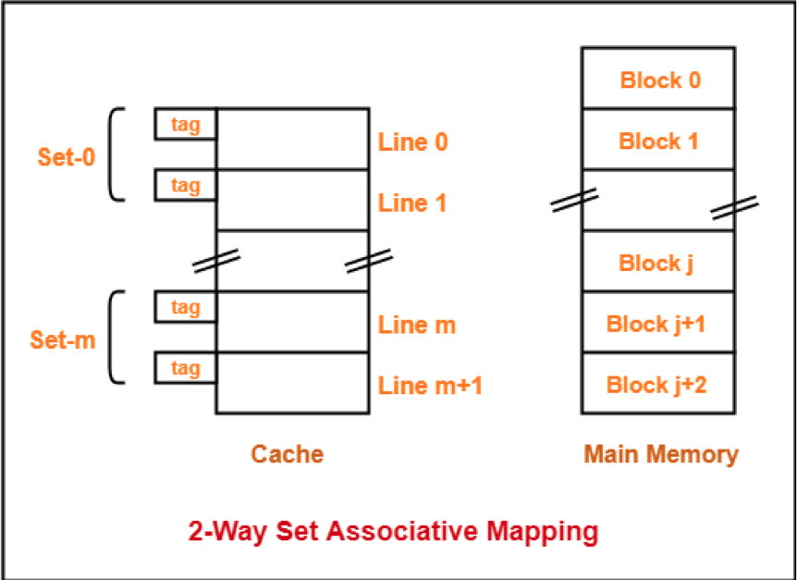

**Advantages**: Provides a compromise between flexibility and reduced conflicts, better cache utilization compared to direct mapping.

**Disadvantages:** Higher hardware complexity than direct mapping.

In summary, cache mapping techniques determine how data is mapped between the main memory and the cache memory. Direct mapping assigns each memory block to a specific cache location, associative mapping allows flexibility in mapping, and set-associative mapping is a compromise between the two. The choice of cache mapping strategy impacts cache performance and is influenced by factors such as hardware complexity, access time, and cache utilization.

5: **How the instruction word size is classified in 8085 microprocessors.**

Ans:

In the 8085microprocessor architecture, the instruction word size is classified as 8-bit. The 8085 microprocessor uses 8-bit instructions, which means each instruction is represented by an 8-bit binary code. These instructions are stored in memory and fetched by the microprocessor for execution.

The 8-bit instruction word size of the 8085 microprocessor limits the range of instructions and the amount of data that can be directly manipulated in a single instruction. It imposes certain constraints on the complexity and capabilities of the microprocessor compared to architectures with larger instruction word sizes. However, the 8085 microprocessor compensates for this limitation by providing a variety of addressing modes and instructions that allow for effective programming and data manipulation within its 8-bit architecture.

6: **What are the different types of hazards encountered in pipeline processors? Could you provide examples of each type and discuss the corresponding solutions or techniques employed to mitigate these hazards?**

In pipeline processors, hazards are situations that can prevent the pipeline from executing instructions efficiently, leading to pipeline stalls, delays, or incorrect results. The different types of hazards encountered in pipeline processors are as follows:

1. **Structural Hazards:**

Structural hazards occur when the hardware resources required by multiple instructions conflict with each other, preventing simultaneous execution. Some examples include: - Instruction/Data Memory Conflict: When the instruction fetch and data memory access happen simultaneously, leading to contention for the memory bus.

- Register File Read/Write Conflict: When an instruction tries to read a register while another instruction is writing to the same register.

Solutions: Techniques like resource duplication, bypassing, or adding additional hardware to handle multiple conflicting accesses can mitigate structural hazards. For example, employing separate instruction and data caches can alleviate memory conflicts, while implementing separate read and write ports in the register file can address register conflicts.

2. **Data Hazards:**

Data hazards occur when an instruction depends on the results of a previous instruction that is still being processed. There are three types of data hazards:

* Read-after-Write (RAW) Hazard: When an instruction tries to read data that has not yet been written by a previous instruction.
* Write-after-Read (WAR) Hazard: When an instruction tries to write data before a previous instruction finishes reading it.
* Write-after-Write (WAW) Hazard: When two instructions try to write to the same destination register simultaneously.

Solutions: Techniques like forwarding (also known as bypassing) and stalling (or inserting bubbles/nops) can mitigate data hazards. Forwarding allows the result of an instruction to be directly forwarded to the dependent instruction, avoiding the need to wait for it to be written to the register file. Stalling involves inserting pipeline bubbles or nops (no-operation instructions) to delay the dependent instruction's execution until the required data is available.

3. **Control Hazards:**

Control hazards occur when the pipeline encounters a branch or jump instruction, and the subsequent instructions in the pipeline become uncertain or incorrect. This leads to wasted instructions fetched and executed after a branch misprediction.

* Conditional Branch Hazard: When a branch instruction's condition is determined late in the pipeline, causing incorrect instructions to be fetched and executed.
* Control Transfer Hazard: When a control transfer instruction (such as jump or subroutine call) changes the program flow, resulting in incorrect instruction fetches.

Solutions: Techniques like branch prediction, branch target prediction, and speculative execution are employed to mitigate control hazards. Branch prediction predicts the outcome of a conditional branch, allowing the pipeline to continue executing the correct instructions. Speculative execution involves executing instructions based on a predicted branch outcome and then discarding the results if the prediction was incorrect.

These are the major types of hazards encountered in pipeline processors, along with their examples and corresponding mitigation techniques. Implementing appropriate hazard detection and resolution mechanisms is crucial for maximizing pipeline efficiency and performance.

7: **What are the advantages and disadvantages of multithreading in computer architecture? How does multithreading improve performance in computer architecture?**

Ans:

Multithreading in computer architecture refers to the ability of a processor to execute multiple threads concurrently within a single core. Each thread represents a separate sequence of instructions and has its own set of registers and program counter. Multithreading offers several advantages and disadvantages:

**Advantages of Multithreading:**

1. **Increased Processor Utilization**: By allowing multiple threads to run concurrently, multithreading improves processor utilization. It helps keep the processor busy even when some threads are stalled due to various reasons, such as memory access or I/O operations. This can lead to higher overall throughput and improved performance.

1. **Reduced Latency:** Multithreading can help reduce the latency of long-latency operations, such as cache misses or memory accesses. While one thread is waiting for a memory operation to complete, the processor can switch to another thread, effectively hiding the latency and keeping the pipeline active.

1. **Improved Responsiveness**: With multithreading, a processor can execute multiple threads simultaneously, which can enhance the responsiveness of the system. This is particularly beneficial in systems that require quick response times, such as real-time applications or interactive user interfaces.

1. **Resource Sharing:** Multithreading allows for efficient resource sharing among threads. Threads running on the same core can share resources like caches, instruction fetch units, and execution units, reducing the overall hardware requirements and cost.

**Disadvantages of Multithreading:**

1. **Increased Complexity**: Multithreading adds complexity to the hardware design and software programming. Managing multiple threads concurrently requires careful synchronization and coordination mechanisms to ensure correct execution and avoid data races or conflicts.

1. **Thread Interference**: In a multithreaded environment, threads can interfere with each other, leading to potential performance degradation or unexpected results. Synchronization overhead and contention for shared resources can limit the scalability and efficiency of multithreaded applications.

1. **Overhead:** Multithreading introduces additional overhead due to thread context switching, synchronization primitives, and managing multiple thread states. This overhead can sometimes outweigh the benefits of concurrency, especially in applications with low thread-level parallelism.

**How Multithreading Improves Performance:**

1. **Overlapping Latency**: Multithreading allows the processor to switch between threads while waiting for long-latency operations, such as memory accesses or I/O operations. This overlapping of latency hides the idle time of the processor and improves performance by keeping the pipeline active.

1. **Increased Throughput**: By executing multiple threads concurrently, multithreading improves overall system throughput. It allows the processor to utilize available resources more efficiently, executing instructions from multiple threads in parallel and potentially completing more work per unit of time.

1. **Responsiveness and Interactivity**: Multithreading enhances system responsiveness by allowing concurrent execution of threads. This can improve user experience in interactive applications, as the system can respond to user inputs or events without being blocked by long running operations in other threads.

In summary, multithreading in computer architecture offers advantages such as increased processor utilization, reduced latency, improved responsiveness, and resource sharing. However, it also comes with challenges like increased complexity, potential thread interference, and overhead. Overall, multithreading improves performance by overlapping latency, increasing throughput, and enhancing system responsiveness.

8: **What is a hexadecimal number system? Give two examples. Explain about its applications**

Ans:

The hexadecimal number system, often referred to as "hex," is a positional numeral system with a base of 16. It uses 16 distinct symbols to represent numbers: the digits 0-9 and the letters A-F (which represent decimal values 10-15). Hexadecimal numbers are widely used in computer science and digital systems due to their convenient representation of binary data.

Here are two examples of hexadecimal numbers:

1. Hexadecimal number "2F":

In decimal, "2F" represents (2 * 16^1) + (15 * 16^0) = 47.

1. Hexadecimal number "A7":

In decimal, "A7" represents (10 * 16^1) + (7 * 16^0) = 167.

**Applications of the Hexadecimal Number System:**

1. **Representation of Binary Data:**

Hexadecimal numbers provide a concise and readable representation of binary data. Since each hexadecimal digit corresponds to a group of four binary digits (bits), it is easier for humans to understand and work with hexadecimal representations of binary data. In computer systems, hexadecimal is often used to represent memory addresses, machine instructions, and byte-level data such as colors, ASCII characters, and file formats.

1. **Programming and Debugging:**

In computer programming and debugging, hexadecimal is frequently used to express memory addresses, register values, and bit patterns. It allows programmers and system developers to examine and manipulate binary data in a more manageable and understandable format. Hexadecimal representations are commonly found in assembly language programming, low-level system programming, and debugging tools.

1. **Computer Networking:**

Hexadecimal is used in computer networking to represent various network-related information. For example, IP addresses and MAC addresses are often represented in hexadecimal format for ease of reading and configuration. Hexadecimal also plays a role in Internet protocols like IPv6 and in configuring network devices.

1. **Color Representation:**

Hexadecimal is widely used to represent colors in graphics and web design. Colors are typically represented using the RGB (Red-Green-Blue) model, where each color component is expressed as an 8-bit value ranging from 0 to 255. Hexadecimal notation provides a compact and intuitive way to represent these RGB values, making it easier to specify and work with colors in various design applications.

1. Digital Electronics and Embedded Systems:

Hexadecimal is extensively used in digital electronics and embedded systems design. It simplifies the representation of binary values in logic circuits and facilitates the understanding and manipulation of digital signals. Hexadecimal numbers are commonly used to specify memory addresses, register values, and data bus information in microcontrollers, field programmable gate arrays (FPGAs), and other digital systems.

In summary, the hexadecimal number system is a base-16 system that uses digits 0-9 and letters A-F. It finds wide application in representing binary data, programming and debugging, computer networking, color representation, and digital electronics. Hexadecimal notation provides a convenient and compact representation of binary data, making it easier for humans to work with and understand digital information.

9: **Convert the following:**

1. To convert the hexadecimal number (A4F)16 into decimal:

(A4F)16 = (10 * 16^2) + (4 * 16^1) + (15 * 16^0)

= (10 * 256) + (4 * 16) + (15 * 1)

= 2560 + 64 + 15

= 2639

Therefore, the hexadecimal number (A4F)16 is equivalent to the decimal number 2639.

1. To convert the decimal number (37)10 into binary:

(37)10 = (100101)2

Therefore, the decimal number (37)10 is equivalent to the binary number (100101)2.

c. To convert the binary number (101.01)2 into decimal:

(101.01)2 = (1 * 2^2) + (0 * 2^1) + (1 * 2^0) + (0 * 2^-1) + (1 * 2^-2)

= (4) + (0) + (1) + (0) + (0.25)

= 5.25

Therefore, the binary number (101.01)2 is equivalent to the decimal number 5.25.

10: **Draw the memory hierarchy. Explain the characteristics of memory based on that figure**

Ans:

The memory hierarchy refers to the organization of different types of memory in a computer system, arranged in a hierarchical structure based on speed, capacity, and cost. The memory hierarchy typically includes several levels, each with different characteristics and purposes. Here are the common levels of the memory hierarchy from the fastest and closest to the CPU to the slowest and furthest:

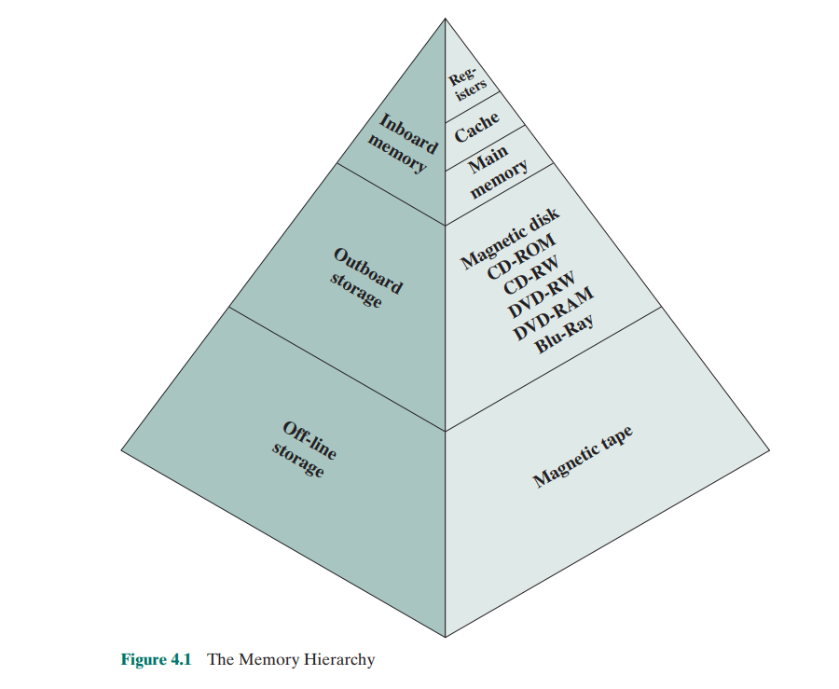

1. **CPU Registers:**

At the top of the memory hierarchy are CPU registers, which are located within the processor itself. Registers are the fastest form of memory and hold small amounts of data that the processor can directly access and operate on.

1. **Cache Memory:**

Next in the hierarchy is cache memory, which is a small, high-speed memory located between the CPU and main memory. Cache memory stores frequently accessed data and instructions to reduce the latency of accessing main memory. It acts as a buffer between the CPU and main memory, providing faster access to frequently used data.

1. **Main Memory (RAM):**

Main memory, also known as Random Access Memory (RAM), is the primary working memory of a computer system. It holds larger amounts of data and instructions that are actively used by the CPU. Main memory is slower than cache memory but faster than secondary storage devices like hard drives. It is volatile, meaning its contents are lost when the power is turned off.

1. **Secondary Storage:**

Secondary storage devices, such as hard disk drives (HDDs) and solid-state drives (SSDs), are used for long-term storage of data and instructions. They have larger capacities but slower access times compared to main memory. Data and instructions must be transferred between secondary storage and main memory for execution by the CPU.

1. **Tertiary Storage**:

Tertiary storage refers to removable storage media, such as magnetic tapes or optical discs. These are typically used for backup, archiving, or long-term storage purposes. Tertiary storage devices have even slower access times compared to secondary storage.

**The characteristics of memory based on this hierarchy are as follows:**

* **Speed:** The memory hierarchy is designed to provide varying levels of speed. Registers and cache memory offer the fastest access times, while main memory, secondary storage, and tertiary storage gradually have slower access times.
* **Capacity**: The capacity of memory increases as we move down the hierarchy. CPU registers have the smallest capacity, followed by cache memory, main memory, secondary storage, and tertiary storage, which typically has the largest capacity.

* **Cost:** As we move down the memory hierarchy, the cost per unit of storage generally decreases. Registers and cache memory are expensive to manufacture due to their high-speed and low-latency requirements, while secondary and tertiary storage devices offer larger capacities at lower costs.

* **Volatility**: Registers, cache memory, and main memory are volatile, meaning their contents are lost when power is turned off. Secondary and tertiary storage devices are non-volatile, allowing data to be retained even when power is removed.

Overall, the memory hierarchy is designed to optimize the trade-offs between speed, capacity, and cost, ensuring that frequently accessed data is stored in faster and more expensive memory levels, while less frequently used data is stored in larger and less expensive levels. This hierarchical arrangement aims to provide a balance between performance and cost-effectiveness in computer systems.

11: **Explain about the flags used in 8085 microprocessors.**

**Ans:**

The 8085 microprocessor, an 8-bit microprocessor developed by Intel, includes several flags that indicate the status or result of an operation. These flags are bits within a register called the flags register (also known as the status register). The flags in the 8085 microprocessor are:

1. **Sign Flag (S):**

The Sign flag is set if the result of an arithmetic or logical operation is negative. It checks the most significant bit (MSB) of the result. If the MSB is 1, the sign flag is set to 1; otherwise, it is set to 0.

1. **Zero Flag (Z):**

The Zero flag is set when the result of an operation is zero. If all the bits of the result are 0, the zero flag is set to 1; otherwise, it is set to 0.

1. **Auxiliary Carry Flag (AC):**

The Auxiliary Carry flag is set if there is a carry from bit 3 to bit 4 during arithmetic operations. It is used for BCD (Binary-Coded Decimal) arithmetic.

1. **Parity Flag (P):**

The Parity flag indicates the parity of the result. It is set to 1 if the result contains an even number of 1 bits; otherwise, it is set to 0.

1. **Carry Flag (CY):**

The Carry flag is set when there is a carry out from the most significant bit (bit 7) during arithmetic operations. It is also used for borrow or borrow-out operations.

These flags provide information about the result of arithmetic, logical, and comparison operations performed by the microprocessor. They are used to make decisions and perform conditional branching based on the outcome of these operations. For example, conditional jump instructions can be executed depending on the state of the zero, sign, carry, or parity flags.

Programmers can access and modify the flag values using specific instructions or conditional statements in assembly language programming. The flags can be tested using conditional branch instructions or by examining their values directly.

Understanding the state of these flags is important for writing efficient and correct programs for the 8085 microprocessor, as they provide information about the results of various operations and enable conditional branching based on those results.

12: **Define cache memory. What are the different types of cache mapping techniques?**

Ans:

Cache memory is a small, high-speed memory component that sits between the CPU and main memory in a computer system. It is used to store frequently accessed data and instructions, reducing the latency of memory access and improving overall system performance. Cache memory operates on the principle of locality, which states that programs tend to access data and instructions that are spatially or temporally close to each other.

There are three primary types of cache mapping techniques used to determine how data is placed in the cache:

1. **Direct Mapping:**

In direct mapping, each block of main memory can be mapped to only one specific cache location. The mapping is determined by the index bits of the memory address. The advantage of direct mapping is its simplicity, as each memory block has a unique location in the cache. However, it can lead to conflicts when multiple memory blocks try to map to the same cache location, resulting in cache misses.

1. **Set-Associative Mapping:**

Set-associative mapping is a compromise between direct mapping and fully associative mapping. It allows multiple memory blocks to be mapped to a set of cache locations. The cache is divided into a number of sets, each consisting of a fixed number of cache locations. The mapping is determined by both the index bits and a subset of the tag bits of the memory address. This technique reduces conflicts compared to direct mapping but introduces more complexity in cache management.

1. **Fully Associative Mapping:**

In fully associative mapping, any memory block can be placed in any cache location. There are no restrictions on the mapping, and the cache uses all the available tag bits to determine the location. This provides the most flexibility and eliminates conflicts entirely. However, it requires more hardware and incurs higher overhead for searching the cache.

Each cache mapping technique has its advantages and trade-offs. Direct mapping is simple and efficient but can lead to conflicts. Set-associative mapping balances between simplicity and flexibility. Fully associative mapping offers maximum flexibility but requires more hardware and has higher search complexity.

Cache memory plays a crucial role in bridging the speed gap between the CPU and main memory. By storing frequently accessed data and instructions, cache memory reduces the number of memory accesses to the slower main memory, improving the overall performance of the system. The selection of a cache mapping technique depends on factors such as system requirements, cost, and performance goals.

13: **Compare TCP/IP with the OSI layer.**

Ans:

TCP/IP (Transmission Control Protocol/Internet Protocol) and the OSI (Open Systems Interconnection) layer are both networking models used to describe and standardize the communication protocols in computer networks. While they serve similar purposes, there are differences in their design and organization.

1. **Layers:**

The OSI model consists of seven distinct layers, each responsible for specific functions and protocols. These layers are: Physical, Data Link, Network, Transport, Session, Presentation, and Application. On the other hand, TCP/IP is a four-layer model that includes the Network Interface, Internet, Transport, and Application layers. The TCP/IP model combines multiple functionalities into broader layers.

1. **Standardization:**

The OSI model was developed as a conceptual framework to guide the development of network protocols and facilitate interoperability between different vendors and systems. It serves as a reference model for network architecture. In contrast, TCP/IP was initially developed as a protocol suite for the early Internet and gradually became the de facto standard for communication in today's global Internet.

1. **Protocols:**

The OSI model is accompanied by a set of protocols specifically designed for each layer. For example, at the Network layer, there are protocols like IP (Internet Protocol) and ICMP (Internet Control Message Protocol). The TCP/IP model also has its own set of protocols, including TCP (Transmission Control Protocol) and IP (Internet Protocol). However, TCP/IP protocols are more commonly used and widely implemented in modern networking.

1. **Layer Interactions:**

In the OSI model, each layer provides services to the layer above it and uses services from the layer below it. This strict layering ensures modularity and separation of concerns. In TCP/IP, the layers are less distinct, and interactions between layers may be more flexible and interconnected. For example, the TCP layer of TCP/IP combines functions of both the Transport and Session layers of the OSI model.

1. **Adoption and Compatibility:**

TCP/IP has gained widespread adoption and is the foundation of the modern Internet. It is supported by most operating systems and networking devices. In contrast, the OSI model is primarily used as a reference model for educational and theoretical purposes. However, many networking protocols and technologies adhere to or are influenced by the concepts of the OSI model.

In summary, TCP/IP and the OSI model are both networking models used to standardize communication protocols. TCP/IP is more widely adopted, while the OSI model provides a conceptual framework for understanding and designing network protocols. While the OSI model has more layers and emphasizes strict layering, TCP/IP has a simpler four-layer structure and combines certain functionalities. Both models serve as important references for network architecture and protocol design.

14: **Differentiate between combinational and sequential circuits with their examples.**

Ans:

Combinational and sequential circuits are two fundamental types of digital circuits used in digital electronics. They differ in terms of their internal structure, behavior, and the way they process input signals.

1. **Combinational Circuits:**

Combinational circuits are digital circuits where the output depends solely on the current values of the input signals. The output is a direct result of the logic function applied to the inputs. These circuits do not have any internal memory elements or feedback loops. The output is determined by the input values at that particular moment, and there is no concept of past or future inputs.

Examples of combinational circuits include:

* Logic gates (AND, OR, NOT, XOR, etc.)
* Multiplexers (MUX)
* Decoders
* Arithmetic logic units (ALUs)
* Comparator circuits

2. **Sequential Circuits:**

Sequential circuits are digital circuits that utilize memory elements to store information and have outputs that depend not only on the current input but also on the previous history of inputs. These circuits have internal feedback loops, which allow them to remember past inputs and produce outputs based on both the current and previous inputs.

Examples of sequential circuits include:

* Flip-flops (SR, D, JK, T, etc.)
* Registers - Counters
* Shift registers
* Memory units (RAM, ROM)
* Finite State Machines (FSMs)

Sequential circuits have a state or internal memory that evolves over time, enabling them to perform tasks that involve sequential logic, memory, and timing requirements. They can store and process data over multiple clock cycles, making them suitable for applications that require memory, synchronization, and control.

In summary, the key difference between combinational and sequential circuits lies in their internal structure and behavior. Combinational circuits produce outputs based solely on the current inputs, while sequential circuits have memory elements that enable them to retain information from previous inputs and produce outputs based on both current and past inputs.

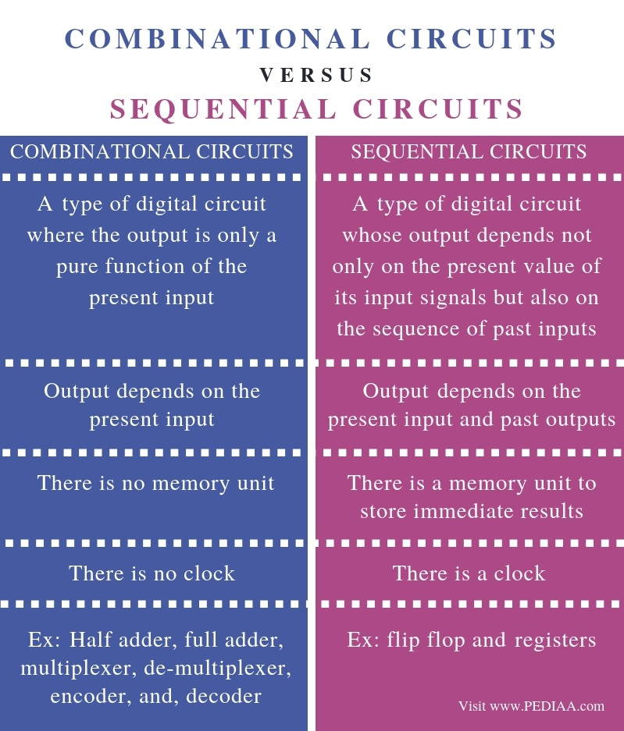

15: **What is the relationship between complementary representation and sign-and-magnitude representation for positive numbers?**

**Ans:**

Complementary representation and sign-and-magnitude representation are two different ways of representing signed numbers in digital systems. However, for positive numbers, there is a relationship between these two representations.

1. Complementary Representation:

In complementary representation, the most significant bit (MSB) is used to represent the sign of the number, where '0' indicates a positive number and '1' indicates a negative number. The remaining bits represent the magnitude of the number. To obtain the complement of a positive number, all the bits are inverted (flipped) to their opposite values.

1. Sign-and-Magnitude Representation:

In sign-and-magnitude representation, the MSB is also used to represent the sign of the number. However, unlike complementary representation, the remaining bits directly represent the magnitude of the number without any further manipulation.

The relationship between complementary representation and sign-and-magnitude representation for positive numbers is that they are identical. When representing positive numbers, both representations will have the MSB set to '0' to indicate a positive sign, and the remaining bits will represent the magnitude of the number.

For example, let's consider a 4-bit representation:

* Complementary Representation:

Positive number: 0110 (6 in decimal)

* Sign-and-Magnitude Representation:

Positive number: 0110 (6 in decimal)

As you can see, the representations are the same for positive numbers. The MSB is '0', indicating a positive sign, and the remaining bits represent the magnitude of the number.

However, it's important to note that the representations differ for negative numbers. In complementary representation, negative numbers are obtained by taking the complement of the positive number, while in sign-and-magnitude representation, the MSB is set to '1' to indicate a negative sign.

16: **What does DMA stand for? What capability does DMA add to a computer?**

Ans:

DMA stands for Direct Memory Access. It is a feature or capability that adds efficient data transfer between devices and memory without the direct involvement of the CPU (Central Processing Unit). DMA allows devices such as hard drives, network cards, and sound cards to transfer data directly to and from memory, bypassing the CPU's intervention.

The primary purpose of DMA is to offload data transfer tasks from the CPU, which frees up the CPU's processing power for other tasks. Without DMA, the CPU would need to handle all data transfers between devices and memory, resulting in increased CPU utilization and reduced overall system performance.

By using DMA, the device initiates the transfer and communicates directly with the memory controller to access or store data. The CPU sets up the DMA controller with the necessary parameters, such as the source and destination addresses and the transfer length, and then the DMA controller takes over the data transfer process, allowing the CPU to perform other tasks in parallel.

The advantages and capabilities of DMA in a computer system include:

1. **Improved Performance**: DMA significantly improves the data transfer speed and overall system performance by reducing the CPU's involvement in data transfer operations.

1. **Offloading CPU:** DMA offloads data transfer tasks from the CPU, allowing it to focus on more critical tasks such as processing instructions and running applications.

1. **Reduced Latency**: DMA reduces the latency associated with data transfers by eliminating the need for the CPU to handle each transfer individually.

1. **Enhanced I/O Operations:** DMA enables efficient data transfers between I/O devices (such as disk drives, network cards, and graphics cards) and memory, facilitating faster and smoother I/O operations.

1. **Concurrent Operations**: DMA enables concurrent data transfers, allowing the CPU to execute instructions and perform computations while data transfers are being carried out.

Overall, DMA enhances the efficiency and performance of a computer system by enabling direct data transfers between devices and memory, reducing CPU overhead, and enabling concurrent operations.

17: **Explain briefly about the bus structure of 8085.**

Ans:

The 8085 microprocessor uses a bus-based architecture to facilitate communication and data transfer between its various components. The bus structure of the 8085 consists of three primary types of buses:

1. **Address Bus:**

The address bus is a unidirectional bus that carries the memory address information from the microprocessor to the memory or I/O devices. The 8085 has a 16-bit address bus, which means it can address up to 2^16 (64K) memory locations.

1. **Data Bus:**

The data bus is a bidirectional bus that carries data between the microprocessor and memory or I/O devices. The 8085 has an 8-bit data bus, allowing it to transfer 8 bits of data at a time.

1. **Control Bus:**

The control bus consists of various control signals that coordinate and control the operations of the microprocessor and the connected devices. Some of the important control signals in the 8085 microprocessor include:

* RD (Read): This signal indicates that the microprocessor wants to read data from memory or an I/O device.
* WR (Write): This signal indicates that the microprocessor wants to write data to memory or an I/O device.
* ALE (Address Latch Enable): This signal indicates that the address on the address bus is valid and should be latched by external devices.
* IO/M (Input/output or Memory): This signal differentiates whether the current operation is an I/O or memory operation.
* INTA (Interrupt Acknowledge): This signal is used to acknowledge an interrupt request. - Control signals for timing and synchronization: These signals include CLK (Clock), RESET (Reset), and various control signals related to instruction execution and bus control.

The bus structure of the 8085 enables the microprocessor to communicate with memory and I/O devices through a standardized set of signals and data pathways. It allows for the transfer of instructions, data, and control signals between different components, facilitating the execution of programs and data exchange in the system.

18: **In simple terms, describe cloud computing. briefly describe the main benefits and risks that an organization might face while adopting cloud computing.**

Ans:

Cloud computing refers to the delivery of computing services over the internet on a pay-as-yougo basis. Instead of hosting applications and storing data on local computers or servers, cloud computing allows organizations to access and utilize computing resources, such as servers, storage, databases, software, and networking, through remote servers provided by cloud service providers.

Main Benefits of Cloud Computing:

1. **Scalability:** Cloud computing offers the flexibility to scale computing resources up or down based on the organization's needs. It allows for easy expansion or reduction of resources to accommodate fluctuations in demand.

1. **Cost Efficiency**: Cloud computing eliminates the need for organizations to invest in and maintain their own expensive hardware and infrastructure. They can pay for the resources they actually use, which reduces capital expenditure and enables cost savings.

1. **Accessibility and Remote Collaboration**: Cloud services are accessible from anywhere with an internet connection, enabling users to work remotely and collaborate in real-time. It provides flexibility and enhances productivity.

1. **Reliability and Availability**: Cloud service providers typically offer robust infrastructure with redundant systems, ensuring high availability and reliability. Data backups and disaster recovery mechanisms are often built-in, minimizing the risk of data loss.
2. Automatic Updates and Maintenance: Cloud service providers handle software updates and maintenance tasks, freeing organizations from the burden of managing these activities themselves. This ensures that the systems are up to date and secure.

Main Risks of Cloud Computing:

1. **Data Security and Privacy**: Storing sensitive data on third-party servers raises concerns about data security and privacy. Organizations must carefully select reputable cloud service providers and implement appropriate security measures to protect their data.

1. **Dependency on Service Providers**: Organizations become reliant on cloud service providers for the availability and performance of their systems. Any disruption or service outage from the provider's end can impact business operations.

1. **Vendor Lock-In:** Moving data and applications between different cloud service providers can be challenging, leading to potential vendor lock-in. Organizations need to consider portability and interoperability when selecting cloud services.

1. **Limited Control**: With cloud computing, organizations have limited control over the underlying infrastructure and resources. They must rely on the service provider for system maintenance, upgrades, and resource management.

1. **Compliance and Legal Issues**: Organizations must ensure that cloud services comply with relevant regulations and legal requirements, especially when dealing with sensitive data or operating in specific industries.

To mitigate these risks, organizations should conduct thorough assessments of their requirements, perform due diligence on cloud service providers, implement robust security measures, backup data regularly, and have contingency plans in place for potential service disruptions.

19: **What are the different modes of I/O Data Transfer? Mention the block diagram of Direct Memory Access (DMA).**

Ans:

The different modes of I/O data transfer in a computer system are:

1. **Programmed I/O (PIO):** In this mode, the data transfer between the I/O device and the CPU is controlled by the CPU itself. The CPU performs the data transfer by reading or writing data from/to the I/O device using specific I/O instructions. PIO mode is simple but relatively slow as it requires continuous CPU involvement.

1. **Interrupt-driven I/O:** In this mode, the I/O device initiates an interrupt request to the CPU when it is ready to transfer data. Upon receiving the interrupt, the CPU suspends its current task, services the interrupt, and performs the data transfer. This mode reduces the CPU's involvement and allows it to perform other tasks while waiting for the I/O device to complete the data transfer.

1. **Direct Memory Access (DMA):** DMA is a mode of I/O data transfer that allows the I/O device to directly transfer data to or from memory without involving the CPU. DMA transfers data in blocks or bursts, bypassing the CPU and significantly improving data transfer rates. The CPU sets up the DMA controller with the necessary parameters, and the DMA controller takes over the data transfer process, communicating directly with the memory and the I/O device.

**Block Diagram of Direct Memory Access (DMA):**

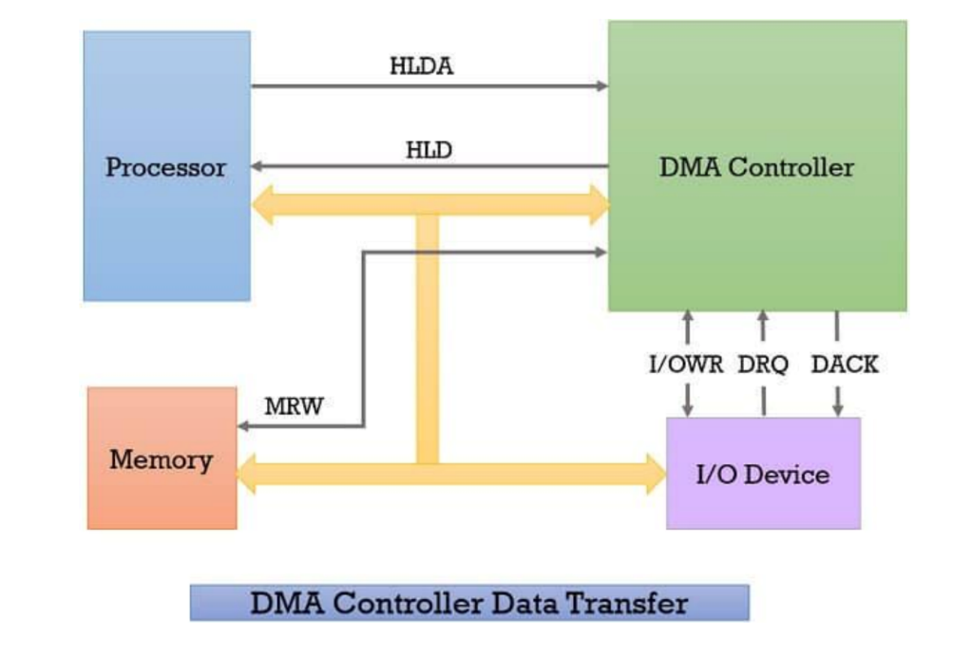

The block diagram of DMA consists of the following components:

1. **I/O Device**: The input or output device, such as a disk drive or network card, that needs to transfer data to or from the memory.

1. **DMA Controller**: The DMA controller coordinates and controls the data transfer between the I/O device and memory. It contains the necessary logic and registers to manage the data transfer process.

1. **DMA Request Signal**: The DMA controller sends a DMA request signal to the CPU to request control of the system bus for data transfer.

1. **DMA Acknowledge Signal**: Once the CPU acknowledges the DMA request, it releases control of the system bus, allowing the DMA controller to take over for data transfer.

1. **Memory**: The destination or source of the data being transferred. The DMA controller directly communicates with memory to perform the data transfer.

The DMA controller manages the data transfer process, allowing the I/O device to directly access memory without CPU intervention, resulting in faster and more efficient data transfer rates.

20: **What is the function of SID and SOD pins in 8085? When the READY signal of the 8085 processor is sampled by the processor?**

Ans:

In the 8085 microprocessor, the SID (Serial Input Data) and SOD (Serial Output Data) pins are used for serial communication.

1. **SID (Serial Input Data):**

The SID pin is an input pin through which the microprocessor can receive serial data. It is used for serial communication with external devices such as serial ports, serial EEPROMs, or other devices that provide data in a serial format. The microprocessor reads the incoming serial data from the SID pin for further processing or storage.

1. **SOD (Serial Output Data):**

The SOD pin is an output pin through which the microprocessor sends serial data. It is used for serial communication with external devices that require data to be transmitted in a serial format. The microprocessor sends the serial data from its internal data bus to the SOD pin, which can then be received by the external device.

The READY signal is used to synchronize the operations of the microprocessor with slower external devices. When the READY signal is sampled by the 8085 processor depends on the specific instruction being executed. The READY signal is typically sampled during certain memory read or memory write operations.

In the case of a memory read operation, the microprocessor waits for the READY signal to be active (low) before it samples the data from the memory. The READY signal indicates that the memory or external device is ready to provide the data to the microprocessor.

Similarly, during a memory write operation, the microprocessor waits for the READY signal to be active (low) before it completes the write operation. The READY signal indicates that the memory or external device is ready to accept the data being written by the microprocessor.

The purpose of sampling the READY signal is to ensure proper coordination and timing between the microprocessor and external devices, especially when the external devices have slower access times or require additional time to process data. It allows for proper synchronization and prevents data loss or corruption during data transfer.

21: **What is meant by Interrupt. Explain priority interrupt of 8085.**

Ans:

In computer systems, an interrupt is a mechanism that allows external devices or internal processes to interrupt the normal execution of a program being executed by the CPU (Central Processing Unit). When an interrupt occurs, the CPU suspends its current task, saves its current state, and transfers control to a specific interrupt handler or interrupt service routine (ISR) that handles the interrupt request. Once the interrupt is serviced, the CPU resumes its previous task.

Interrupts are used for various purposes, such as handling I/O events, responding to hardware interrupts, implementing multitasking, and enabling communication between different parts of a system. They help improve system efficiency, responsiveness, and resource utilization.

Priority Interrupt in 8085:

The 8085 microprocessor supports multiple types of interrupts, and each interrupt has a priority associated with it. The priority interrupt feature allows the microprocessor to handle different interrupts based on their priority levels. The higher-priority interrupt is given precedence over lower-priority interrupts.

In the 8085 microprocessor, there are five interrupt lines that can be used for priority interrupts. These are:

1. **TRAP:**

The TRAP interrupt has the highest priority among all interrupts. It is a non-maskable interrupt and is used for critical events that require immediate attention, such as power failure or system reset. The TRAP interrupt vector address is 0024H.

1. **RST 7.5:**

The RST 7.5 interrupt has the second-highest priority. It is a maskable interrupt and is commonly used for I/O devices. The RST 7.5 interrupt vector address is 003CH.

1. **RST 6.5:**

The RST 6.5 interrupt has the third-highest priority. It is a maskable interrupt and is used for devices requiring lower priority than RST 7.5. The RST 6.5 interrupt vector address is 0034H.

1. **RST 5.5:**

The RST 5.5 interrupt has the fourth-highest priority. It is a maskable interrupt and is used for devices requiring lower priority than RST 6.5. The RST 5.5 interrupt vector address is 002CH.

1. **INTR:**

The INTR interrupt has the lowest priority among the priority interrupts. It is a maskable interrupt and is used for devices requiring the lowest priority. The INTR interrupt vector address is 0020H.

When multiple interrupts occur simultaneously, the 8085 microprocessor follows a priority scheme to determine which interrupt is serviced first. The priority is assigned in the order of TRAP > RST 7.5 > RST 6.5 > RST 5.5 > INTR. Once the highest-priority interrupt is serviced, the microprocessor will check for any pending interrupts with lower priority and service them accordingly.

By using priority interrupts, the 8085 microprocessor ensures that critical or time-sensitive events are given precedence, allowing for efficient handling of different types of interrupts and effective utilization of system resources.

22: **What does BCD stand for? Explain at least two important disadvantages of storing numbers in BCD format. Offer one advantage for using a BCD format for storing numbers.**

Ans:

BCD stands for Binary Coded Decimal. It is a way of representing decimal numbers using a binary system, where each decimal digit is represented by a four-bit binary code.

Two important disadvantages of storing numbers in BCD format are:

1. **Wasted storage space**: BCD requires more storage space compared to other binary representations. Since each decimal digit is represented by four bits, it means that a single BCD digit requires more bits to store compared to a binary digit. This can lead to increased storage requirements, especially when dealing with large numbers or when storing a large set of numbers.

1. **Inefficiency in arithmetic operations**: Performing arithmetic operations directly on BCD numbers can be inefficient. Addition and subtraction operations can be more complex and time-consuming when working with BCD compared to binary representations. BCD arithmetic often involves additional steps to handle carries and overflows, which can slow down calculations and require more processing power.

An advantage of using BCD format for storing numbers is:

1. **Direct human-readable representation**: BCD is a self-explanatory format as each digit is represented by its corresponding binary code. This makes BCD numbers easily readable by humans without requiring any conversion. It can be useful in applications where human readability of stored numbers is important, such as in digital displays or data entry systems where decimal input is required. BCD allows for direct translation

between binary and decimal representations without the need for additional conversion algorithms.

23**: What are the different types of hazards encountered in pipeline processors? Could you provide examples of each type and discuss the corresponding solutions or techniques employed to mitigate these hazards?**

Ans:

In pipeline processors, hazards are situations that can lead to incorrect or unexpected results due to the overlapping execution of instructions in different stages of the pipeline. There are three types of hazards commonly encountered in pipeline processors:

1. **Structural Hazards:**

Structural hazards occur when there are conflicts in accessing shared hardware resources, such as memory or registers. These conflicts can lead to delays or incorrect results. Examples include:

1. **Memory conflicts**: When multiple instructions try to access the same memory location simultaneously, conflicts can occur. To mitigate this, processors employ techniques like memory buffering, cache memory, or multi-level memory hierarchies to reduce memory access contention.

1. **Register conflicts:** If multiple instructions in the pipeline require access to the same register at the same time, conflicts can arise. Processors typically employ register renaming or register file duplication techniques to provide multiple independent copies of the registers, mitigating these conflicts.

**2. Data Hazards:**

Data hazards occur when instructions depend on the data produced by previous instructions in the pipeline. These dependencies can result in incorrect values being used or data being unavailable when needed. Examples include:

1. **Read-after-write (RAW) hazard**: When an instruction depends on the result of a previous instruction that has not yet completed, a RAW hazard occurs. To resolve RAW hazards, processors use techniques like forwarding (also known as bypassing) to forward the data directly from the earlier stage to the dependent instruction, bypassing the need to wait for it to be written to the register file.

1. **Write-after-read (WAR) hazard:** When a previous instruction writes to a register that a subsequent instruction reads from, a WAR hazard occurs. These hazards can be resolved by enforcing a specific order of instructions execution or by using register renaming techniques to provide independent copies of registers.

1. **Write-after-write (WAW) hazard:** When multiple instructions write to the same register, and their order is not preserved, a WAW hazard occurs. Similar to WAR hazards, these can be resolved using instruction ordering or register renaming techniques.

3. **Control Hazards:**

Control hazards occur when the pipeline encounters branch instructions or other control flow instructions that change the normal program execution flow. These hazards can lead to incorrect instruction fetching and instruction completion. Examples include:

1. **Branch hazards:** When a branch instruction is encountered, the subsequent instructions in the pipeline may have been fetched incorrectly. Branch prediction techniques, such as branch target prediction and branch outcome prediction, are employed to minimize the impact of branch hazards by predicting the branch target and pre-fetching the corresponding instructions.

1. **Delayed branch:** A delayed branch instruction allows the execution of one or more instructions after the branch instruction, regardless of whether the branch is taken or not. Delayed branching helps mitigate the impact of branch hazards by filling the pipeline with useful instructions, reducing the number of pipeline stalls.

To mitigate hazards, pipeline processors use a combination of hardware techniques such as forwarding, register renaming, caching, and branch prediction, as well as software techniques like compiler optimizations and instruction reordering. These techniques aim to minimize pipeline stalls and ensure correct execution of instructions in a pipelined environment.

24: **What is BUS? Explain about the bus that connects major computer components (processor, memory, I/O).**

Ans:

In computer architecture, a bus refers to a communication pathway or a set of wires that enables data transfer between different components of a computer system. It acts as a shared medium through which information is exchanged between the processor, memory, and various input/output (I/O) devices.

The bus serves as a conduit for transmitting data, control signals, and addresses within the computer system. It provides a standardized interface that allows different components to communicate with each other efficiently. Here are some key components connected by the bus:

1. **Processor**: The processor, also known as the central processing unit (CPU), is the brain of the computer. It executes instructions and performs calculations. The bus connects the processor to other components, enabling it to fetch instructions, access data from memory, and send/receive data from I/O devices.

1. **Memory**: Memory refers to the storage space where data and instructions are stored for quick access by the processor. The bus connects the processor to different types of memory, such as random access memory (RAM) and read-only memory (ROM). It allows the processor to read and write data to and from memory as needed.

1. **Input/output (I/O) Devices**: I/O devices are used to interact with the computer system, such as keyboards, mice, displays, printers, and storage devices. The bus connects these devices to the processor and memory, facilitating data transfer between the I/O devices and the rest of the system. This allows the processor to send data to output devices or receive data from input devices.

The bus architecture consists of multiple lines, each serving a specific purpose. Here are the common types of lines found in a bus:

1. **Data Lines**: These lines carry the actual data being transferred between components. They can be bidirectional, allowing data to flow in both directions.

1. **Address Lines**: Address lines are unidirectional and carry memory addresses or I/O device addresses. They specify the location where data is to be read from or written to.

1. **Control Lines**: Control lines transmit control signals, which include commands and timing signals, to coordinate the activities of different components. These signals control actions such as data transfer, memory read/write operations, and I/O device operations.

The bus design can vary based on the computer architecture and system requirements. It can be a single bus shared by all components (commonly known as a system bus), or it can be divided into separate buses for different purposes (such as a data bus, address bus, and control bus). The width of the bus, determined by the number of lines, affects the amount of data that can be transferred simultaneously and can impact the system's overall performance.

Overall, the bus serves as a vital communication channel, enabling efficient and reliable data transfer between the processor, memory, and I/O devices in a computer system.

25: **What are the advantages and disadvantages of multithreading in computer architecture? How does multithreading improve performance in computer architecture?**

Ans:

Multithreading in computer architecture refers to the ability of a processor to execute multiple threads concurrently. Each thread represents an independent sequence of instructions that can be scheduled and executed simultaneously, sharing the resources of a single processor core. Here are the advantages and disadvantages of multithreading:

**Advantages of Multithreading:**

1. **Increased throughput:** Multithreading allows multiple threads to execute simultaneously, making better use of available resources. This leads to increased throughput, as the processor can work on multiple tasks concurrently, effectively utilizing its processing power.

1. **Improved responsiveness:** Multithreading enhances system responsiveness by allowing the processor to overlap the execution of multiple threads. This is particularly beneficial in multitasking environments, where multiple applications or processes can run concurrently, providing a more responsive user experience.

1. **Resource utilization**: By sharing the resources of a single core, multithreading maximizes the utilization of processor resources. It helps mitigate resource wastage by keeping the processor busy with other threads when one thread is stalled due to factors like memory access or I/O operations.

1. **Efficient context switching**: Multithreading reduces the overhead of context switching between threads. Since the threads share the same memory space and some processor state, switching between threads is faster compared to switching between independent processes.

**Disadvantages of Multithreading:**

1. **Increased complexity:** Multithreading adds complexity to the design and programming of computer systems. Managing shared resources, ensuring thread safety, and handling synchronization between threads can be challenging and require careful consideration.

1. **Resource contention**: With multiple threads running concurrently, resource contention can occur. Threads may compete for resources such as cache memory, registers, or I/O devices, leading to increased contention and potentially degrading performance.

1. **Dependencies and synchronization**: Multithreading introduces the need for synchronization mechanisms to ensure the correct order of execution and prevent data races or other synchronization-related issues. Synchronization can introduce overhead and potential bottlenecks, particularly when threads frequently access shared data or require exclusive access to resources.

**How Multithreading Improves Performance:**

Multithreading improves performance in computer architecture through the following mechanisms:

1. **Instruction-level parallelism:** Multithreading exploits instruction-level parallelism by overlapping the execution of multiple threads. While one thread may be stalled due to a cache miss or a long-latency operation, another thread can continue execution, utilizing otherwise idle processor resources.

1. **Latency hiding**: Multithreading helps hide the latency of certain operations, such as memory access or I/O operations. While one thread is waiting for data to be fetched from memory or for a slow I/O operation to complete, another thread can continue execution, effectively utilizing the processor's resources.

1. **Utilizing idle resources:** Multithreading allows the processor to utilize idle resources, such as execution units, pipeline stages, or functional units, when one thread is stalled or waiting for resources. This improves overall resource utilization and keeps the processor busy with productive work.

1. **Increased system throughput:** By enabling the execution of multiple threads simultaneously, multithreading increases the system's overall throughput. This is particularly advantageous in scenarios with parallelizable workloads, such as server applications or multimedia processing, where multiple threads can execute independently.

In summary, multithreading in computer architecture provides advantages such as increased throughput, improved responsiveness, and efficient resource utilization. However, it also introduces complexity, resource contention, and synchronization challenges that need to be carefully managed. By effectively exploiting parallelism and hiding latencies, multithreading improves overall performance in computer systems.

26: **Describe the types of computer architecture based on Flynn's classification.**

Ans:

Flynn's classification is a well-known taxonomy for classifying computer architectures based on the number of instruction streams (IS) and data streams (DS) that can be processed concurrently. It defines four categories of computer architecture:

1. **Single Instruction, Single Data (SISD):**

In SISD architecture, only one instruction stream and one data stream are processed at a time. This represents the traditional sequential processing model where a single processor executes instructions sequentially on a single set of data. Examples include most general-purpose CPUs and early computer systems.

1. **Single Instruction, Multiple Data (SIMD):**

SIMD architecture executes a single instruction on multiple data elements simultaneously. The instruction is broadcasted to multiple processing units, and each unit performs the same operation on its respective data element. SIMD is often used in parallel processing for tasks that can be divided into identical computations on multiple data sets. Graphics processing units (GPUs) and vector processors are common examples of SIMD architectures.

1. **Multiple Instruction, Single Data (MISD):**

MISD architecture involves multiple instruction streams operating on a single data stream. This type of architecture is rare and typically not practical for general-purpose computing. It has been explored in specialized areas such as fault-tolerant systems and data analysis, but practical implementations are limited.

1. **Multiple Instruction, Multiple Data (MIMD):**

MIMD architecture allows for concurrent execution of multiple instruction streams on multiple data streams. It represents the most versatile and common type of parallel architecture, as it supports independent execution of different instructions on different data. MIMD systems can range from shared-memory multiprocessors, where multiple processors share a common memory, to distributed systems with independent processors communicating over a network. Clustered computing environments, supercomputers, and modern multi-core processors are examples of MIMD architectures.

It's worth noting that some architectures can exhibit hybrid characteristics, combining elements of multiple Flynn's categories. For example, many modern processors incorporate SIMD instructions alongside MIMD capabilities, providing a combination of parallelism for different types of workloads.

Flynn's classification provides a useful framework for understanding and categorizing different computer architectures based on their concurrency capabilities, which helps guide the design and analysis of parallel processing systems.

27: **Write a program in 8085 assembly language to store 20H number in register H and store 32H number in register B.**

Ans:

Certainly! Here's an example of a program in 8085 assembly language that stores the value 20H in register H and the value 32H in register B:

assembly

MOV H, 20H; Store 20H in register H

MOV B, 32H; Store 32H in register B

In the above program, the "MOV" instruction is used to move the immediate values (20H and 32H) into the respective registers (H and B).

Please note that this program assumes that the 8085 assembly language instructions are executed in sequence, and the registers H and B are available for use.

28: **Among combinational and sequential circuits which circuit is generally used for storing data? Explain it with a block diagram.**

Ans:

Among combinational and sequential circuits, sequential circuits are generally used for storing data. Unlike combinational circuits, which directly depend on the current inputs to produce outputs, sequential circuits have memory elements that enable them to store and remember past inputs.

A sequential circuit consists of a combination of combinational logic and memory elements (flip-flops or latches) to store and manipulate data. The memory elements provide the ability to retain information and pass it from one state to the next, allowing for the storage of data.

Here is a block diagram representation of a sequential circuit:

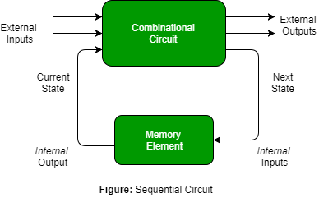

**In the block diagram:**

* **Inputs**: The inputs to the sequential circuit, which can be any combination of bits or signals.
* **Clock:** The clock signal acts as a timing mechanism to control the operation of the circuit. It synchronizes the storage and retrieval of data.
* **Memory Elements:** The circuit includes memory elements such as flip-flops or latches (represented by rectangles with an input D and an output Q). These memory elements store the data and retain it until the next clock cycle.
* **Combinational Logic**: The combinational logic blocks (represented by rectangles with various logical operations) process the inputs and the stored data to produce the desired outputs.
* **Outputs:** The outputs of the circuit, which can be based on the current inputs as well as the stored data.

The combination of memory elements and combinational logic in a sequential circuit allows for the storage of data, as the state of the memory elements is retained until it is updated by the clock signal. This enables the circuit to remember and process previous inputs, making sequential circuits suitable for applications that require memory and data storage, such as registers, counters, and memory units in digital systems.

29: **Give a simple explanation and example for SaaS. Do the same for PaaS. Do the same for IaaS. [4]**

Ans:

Here are simple explanations and examples for Software-as-a-Service (SaaS), Platform-as-a-Service (PaaS), and Infrastructure-as-a-Service (IaaS):

1. **Software-as-a-Service (SaaS):**

SaaS is a cloud computing model where software applications are provided over the internet on a subscription basis. Users can access and use the software through a web browser without the need for installation or management of the underlying infrastructure.

Example: OneDrive is an example of SaaS. It allows users to store, access, and collaborate on files and documents online without the need to install any software. Users can simply log in to their OneDrive account through a web browser and access their files from any device connected to the internet.

1. **Platform-as-a-Service (PaaS):**

PaaS is a cloud computing model that provides a platform or environment for developers to build, deploy, and manage applications. It offers a set of tools, libraries, and services that developers can use to develop and customize their applications without worrying about the underlying infrastructure.

Example: Heroku is an example of PaaS. It provides a cloud platform where developers can build, deploy, and scale their web applications without managing servers or infrastructure. Developers can focus on writing code and utilizing the platform's services and tools to deploy their applications easily.

1. **Infrastructure-as-a-Service (IaaS):**

IaaS is a cloud computing model that provides virtualized computing resources over the internet. It offers scalable and flexible infrastructure components such as virtual machines, storage, and networking resources that users can provision and manage according to their needs.

Example: Amazon Web Services (AWS) is an example of IaaS. It offers a wide range of virtualized infrastructure services like EC2 (Elastic Compute Cloud) for virtual machines, S3 (Simple Storage Service) for storage, and VPC (Virtual Private Cloud) for networking. Users can provision and configure these resources as per their requirements without the need to invest in physical hardware.

30: **Using appropriate gates draw the circuit diagram for the following Boolean function: F = (A + B + C). (A’ + B’ +C). (A + B’ + C)**

To draw the circuit diagram for the Boolean function F = (A + B + C).(A' + B' + C).(A + B' + C), we can start by simplifying the expression and applying Boolean algebra to minimize the number of gates required. Here's the step-by-step process:

1. Simplify the Boolean expression:

F = (A + B + C). (A' + B' + C). (A + B' + C)

2. Apply Boolean algebra rules:

F = (A + B + C). (A' + B' + C). (A + B' + C)

= (A + B + C). (A' + B' + C)

3. Expand the expression:

F = (A'A' + A'B' + A'C + AB + BB' + BC + AC + B'C + CC). (A + B' + C)

= (A'B' + A'C + AB + BC + AC + B'C + C). (A + B' + C)

4. Distribute the terms:

F = A'B'A + A'B'B' + A'B'C + A'BC + AC + AB'C + BB'A + BB'B' + BB'C + BBC + BC'C + CC'A +

CC'B + CC'C

= A'B'C + A'BC + AC + AB'C + BC'C + CC'A + CC'B

5. Draw the circuit diagram:

We can now draw the circuit diagram using AND, OR, and NOT gates based on the simplified expression. Each term in the simplified expression will correspond to a gate or combination of gates. Here's the circuit diagram:

```

______

1. ----| |

| AND |-------- F

1. ----|______|

______

B' ---| |

| AND |-------- F

1. ----|______|

______

A' ---| |

| AND |-------- F

C ----|______|

______

B' ---| |

| AND |-------- F

C ----|______|

______

1. ----| |

| OR |-------- F

B' ---|______|

______

1. ----| |

| OR |-------- F

1. ----|______|

______

A ----| |

| OR |-------- F

C ----|______|

______

1. ----| |

| OR |-------- F

1. ----|______|

______

1. ----| |

| OR |-------- F

A' ---|______|

______

C ----| |

| OR |-------- F B' ---|______|

______

1. ----| |

| OR |-------- F

C' ---|______|

______

1. ----| |

| OR |-------- F

C' ---|______|

```

Note: In the circuit diagram, the inputs A, B, and C are connected to their respective gates (AND or OR) and the outputs are connected to the final OR gate to obtain the output F.